Online Payments Fraud Detec on using ML
Team - 592416

Project Descrip on
The surge in online credit/debit card transac ons has led to an upsurge in fraud. To combat this, we're employing classifica on algorithms like Decision Trees, Random Forest, SVM and XGBoost. Using a vast dataset, we'll train and evaluate these models, selec ng the one with the highest accuracy, precision, and a low false posi ve rate. The chosen model will be saved in pkl format. We'll integrate it into a Flask web applica on for real- me fraud detec on. This project aims to enhance fraud detec on, improve user experience, save costs, and offer real-
me protec on.

Technical Architecture
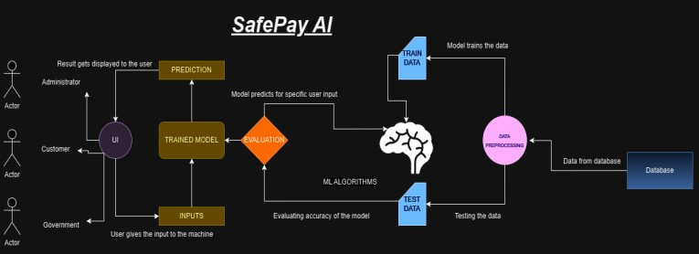

Pre requisites:
To complete this project, you must required following so ware’s, concepts and packages
- Anaconda navigator and pycharm: o Refer the link below to download anaconda navigator o Link : h ps://youtu.be/1ra4zH2G4o0
- Python packages: o Open anaconda prompt as administrator o Type“pip install numpy”and click enter. o Type“pip install pandas”andclickenter. o Type“pip install scikit-learn”andclickenter. o Type”pip install matplotlib”andclickenter. o Type”pip install scipy”andclickenter. o Type”pip install pickle-mixin”andclickenter. o Type”pip install seaborn”andclickenter. o Type“pipinstallFlask”and click enter.

Prior Knowledge:
You must have prior knowledge of following topics to complete this project.
- ML Concepts o Supervisedlearning:
h ps://www.javatpoint.com/supervised-machine-learning o Unsupervisedlearning:
h ps://www.javatpoint.com/unsupervised-machine-learning o Regression and classifica on o Decisiontree:
h ps://www.javatpoint.com/machine-learning-decision-tree-classifica o n-algorithm o Randomforest:
h ps://www.javatpoint.com/machine-learning-random-forest-algorithm o xgboost Classifier
h ps://www.javatpoint.com/xgboost-classifier-algorithm-for-machine-le arning o Svm:
h ps://www.analy csvidhya.com/blog/2018/09/an-end-to-end-guide-to- understand-the-math-behind-Svm/ o Evalua onmetrics:
h ps://www.analy csvidhya.com/blog/2019/08/11-important-model-eva lua on-error-metrics/
  - Flask Basics : h ps://www.youtube.com/watch?v=lj4I_CvBnt0

Project Objec ves:
By the end of this project you will:
- Know fundamental concepts and techniques used for machine learning.
- Gain a broad understanding about data.
- Have knowledge on pre-processing the data/transforma on techniques on outlier and some visualisa on concepts.

Project Flow:
- User interacts with the UI to enter the input.
- Entered input is analysed by the model which is integrated.
- Once model analyses the input the predic on is showcased on the UI

To accomplish this, we have to complete all the ac vi es listed below,
- Data collec on o Collect the dataset or create the dataset
- Visualising and analysing data
Impor ng the libraries o Read the Dataset o Univariate analysis o Bivariate analysis o Descrip ve analysis
- Data pre-processing o Checking for null values o Handling outlier
  - Handling categorical(object) data o Spli ng data into train and test
- Model building o Import the model building libraries o Ini alising the model o Training and tes ng the model o Evalua ng performance of model o Save the model
- Applica on Building o Create an HTML file o Build python code

Project Structure:
Create the Project folder which contains files as shown below
- We are building a flask applica on which needs HTML pages stored in the templates folder and a python script app.py for scrip ng.
- Model.pkl is our saved model. Further we will use this model for flask integra on.
- Training folder contains model training files

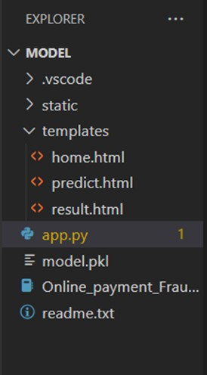

Process - 1 : Data Collec on
In this project we have used PS_20174392719_1491204439457_logs.csv data. This data is downloaded from kaggle.com. Please refer to the link given below to download the dataset.
Link: h ps://www.kaggle.com/datasets/rupakroy/online-payments-fraud-detec on-dataset
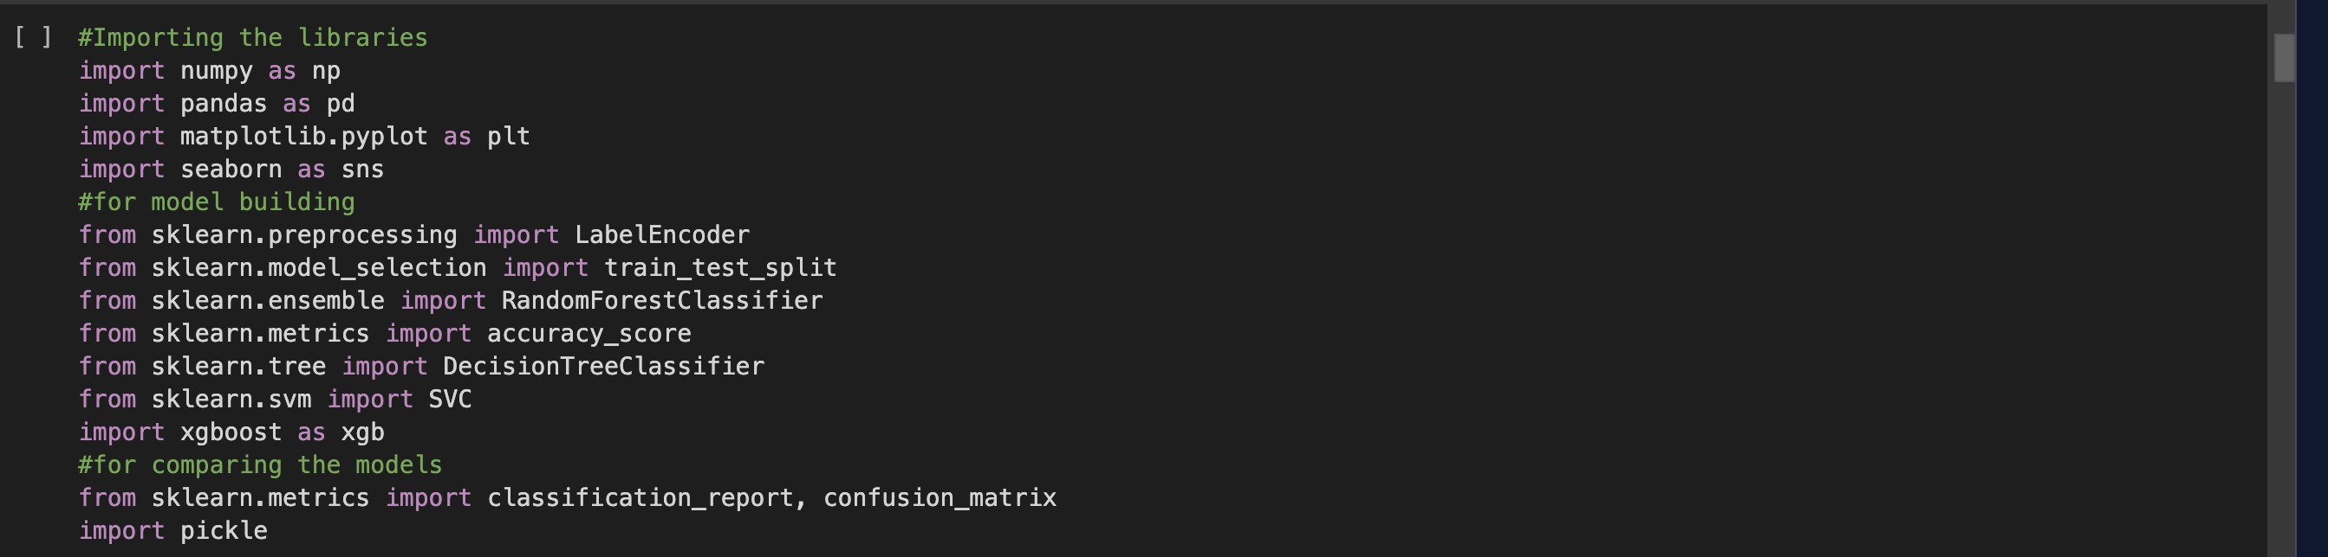

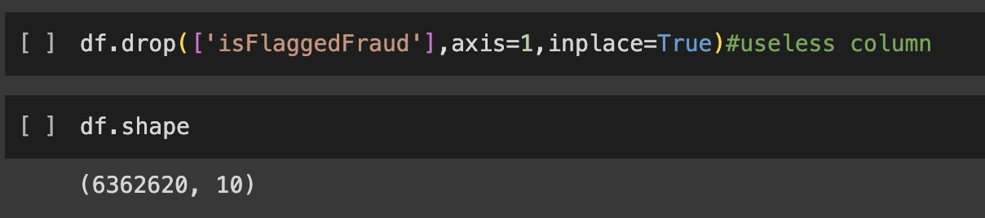

Descrip ve Analysis
Descrip ve analysis is to study the basic features of data with the sta s cal process. Here pandas has a worthy func on called describe. With this describe func on we can understand the unique, top and frequent values of categorical features. And we can find mean, std, min, max and percen le values of con nuous features.
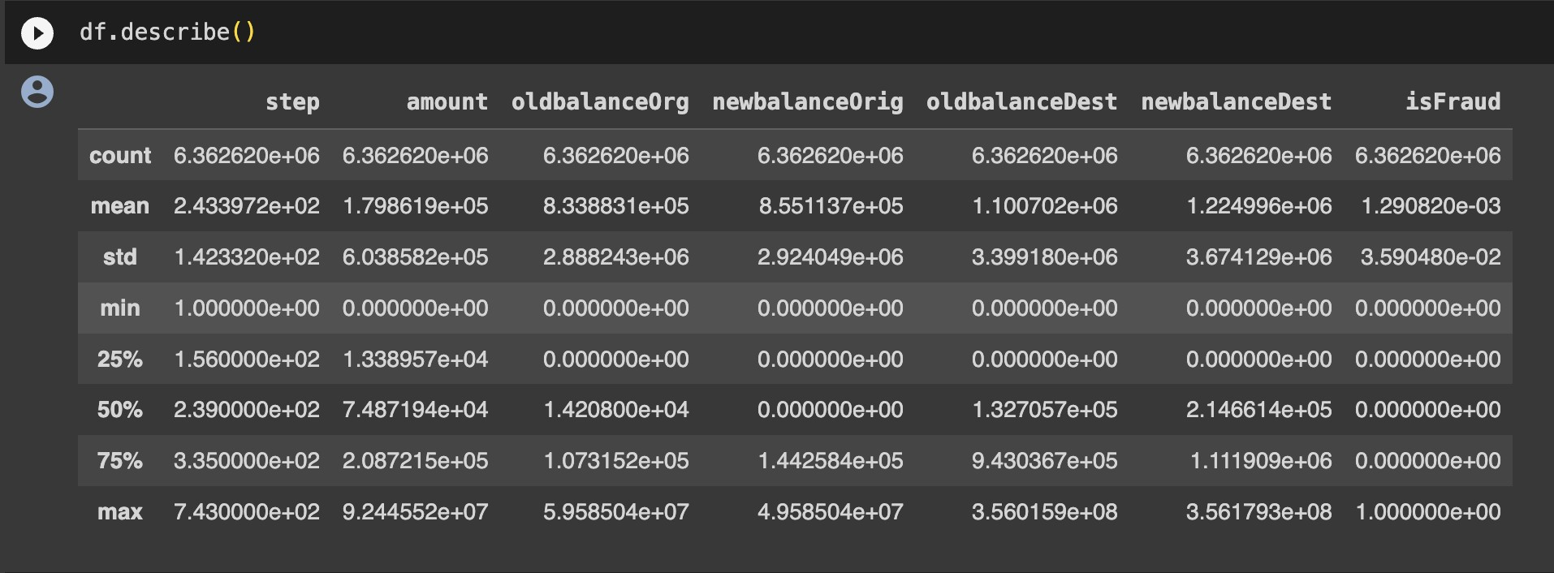

Visualizing and analysing Data
'step': Transac on me step.
'type': Transac on type.
'amount': Transac on amount.
'oldbalanceOrg': Original sender's balance.
'newbalanceOrig': Updated sender's balance.
'oldbalanceDest': Original recipient's balance.
'newbalanceDest': Updated recipient's balance.
'isFraud': Indicates if the transac on is fraudulent.

The df.info() func on in Python, when applied to a DataFrame 'df', provides a concise summary
of the DataFrame's structure. It displays the number of non-null entries, data types of each column, memory usage, and addi onal informa on like the count of non-null values, facilita ng quick data assessment and iden fica on of missing values or data types. This method is useful for an ini al data explora on and understanding the dataset's characteris cs.

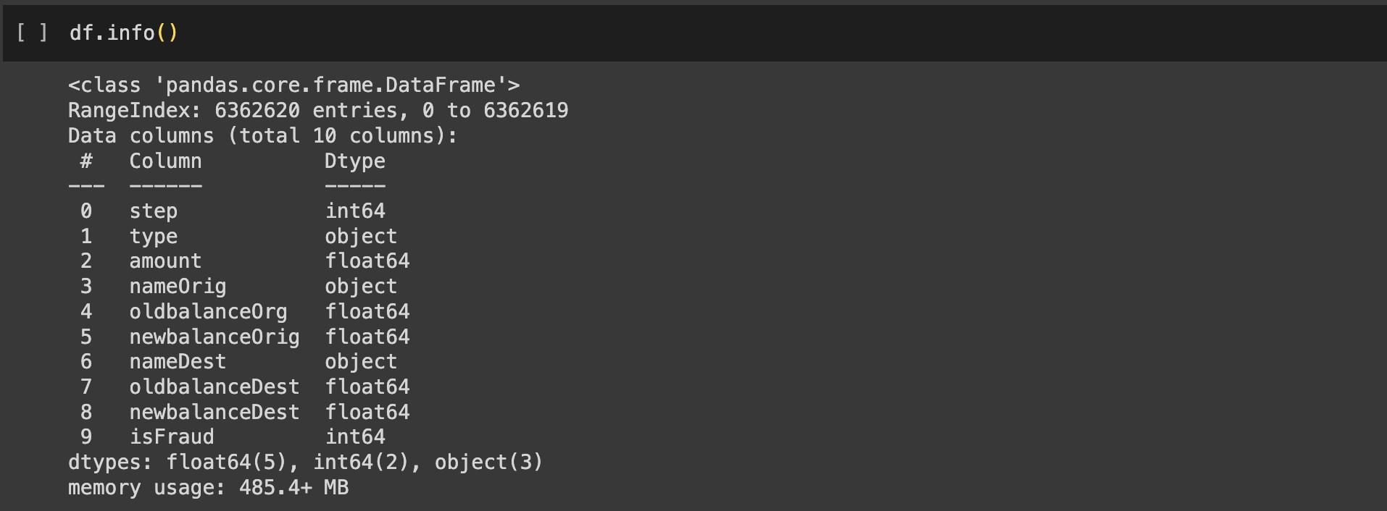

df.isnull().sum(), a result of "no null values" indicates that there are no missing (null) values in the DataFrame. This is a posi ve outcome, sugges ng that the dataset is complete with no missing data, which is typically preferred for analysis and modeling.
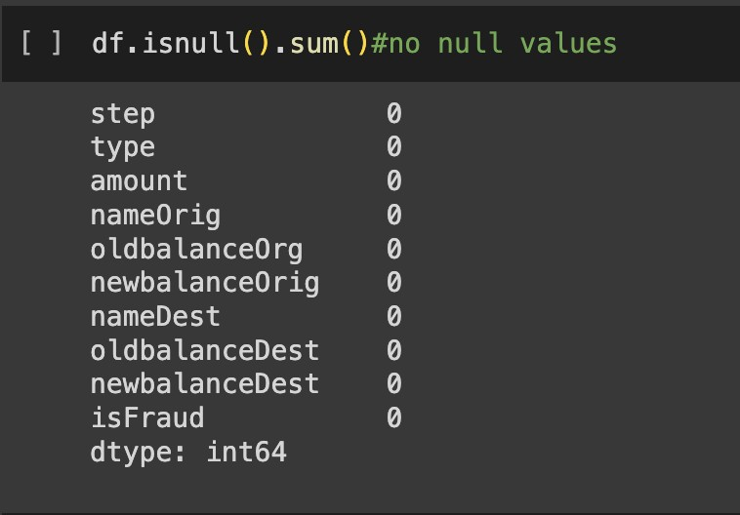

The df.corr() func on in Python, when applied to a DataFrame 'df', computes the pairwise correla on between numeric columns, providing a correla on matrix. This matrix offers insights into the strength and direc on of linear rela onships between variables, with values ranging from -1 to 1, where -1 represents a strong nega ve correla on, 1 indicates a strong posi ve correla on, and 0 signifies no linear correla on. It's a valuable tool for understanding associa ons between data features.

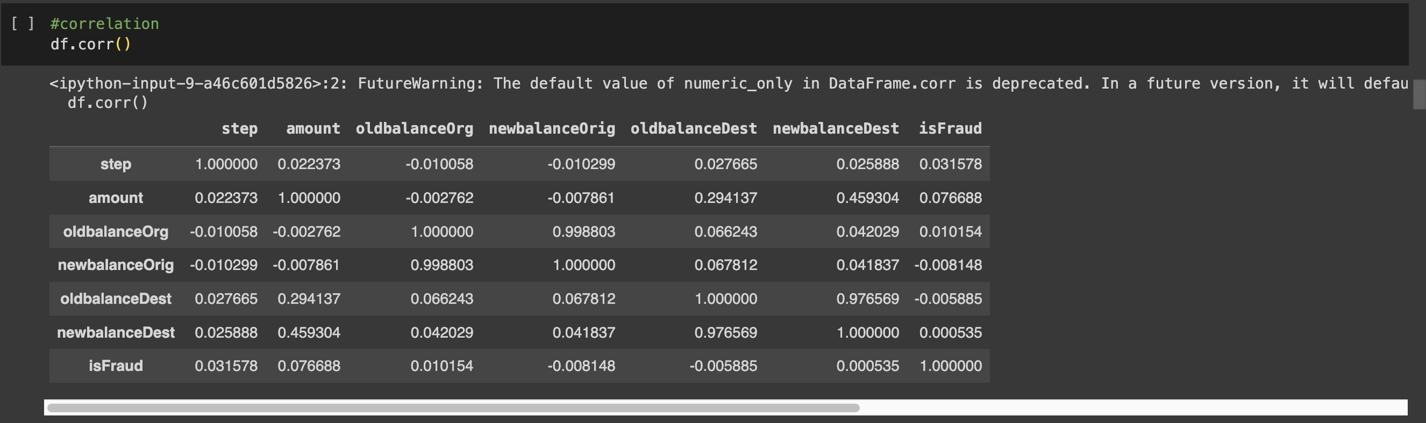

Univariate Analysis
Univariate analysis examines one variable's characteris cs and distribu on.

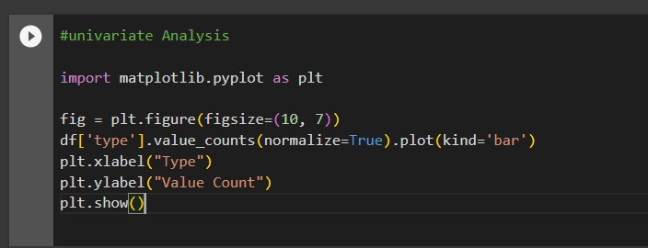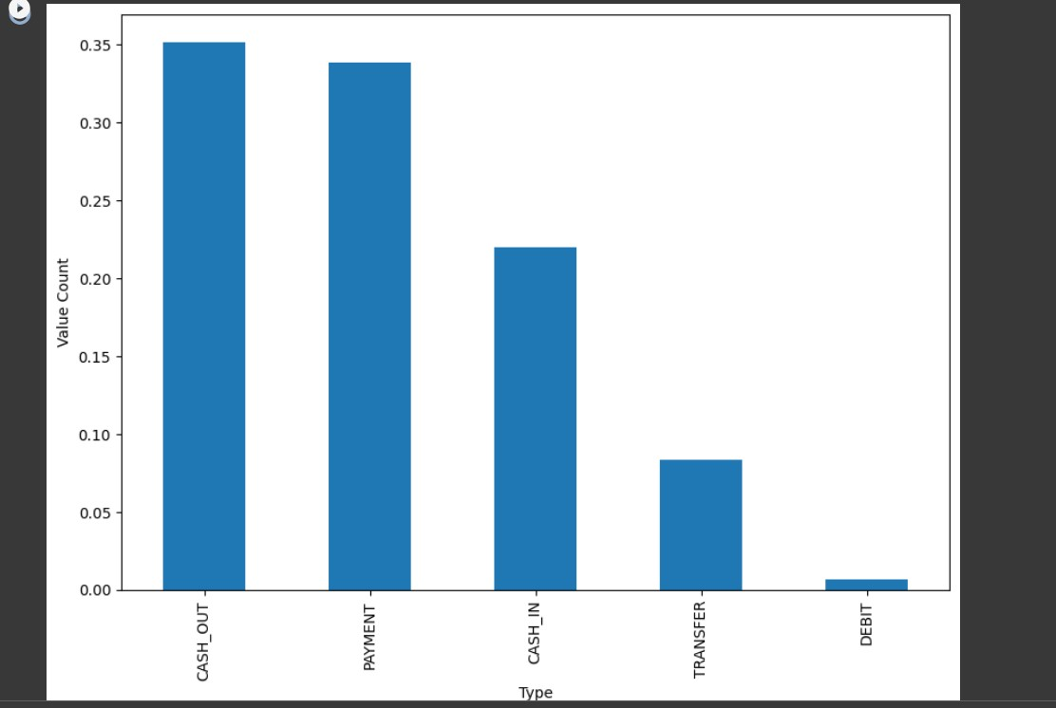

Boxplot
A boxplot is a graphical summary of a variable's distribu on, showing its median, quar les, and poten al outliers.
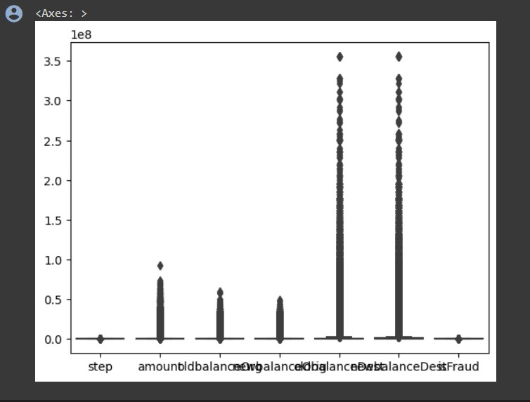

Countplot
A countplot is a type of bar plot that displays the frequency of categorical data in a dataset.
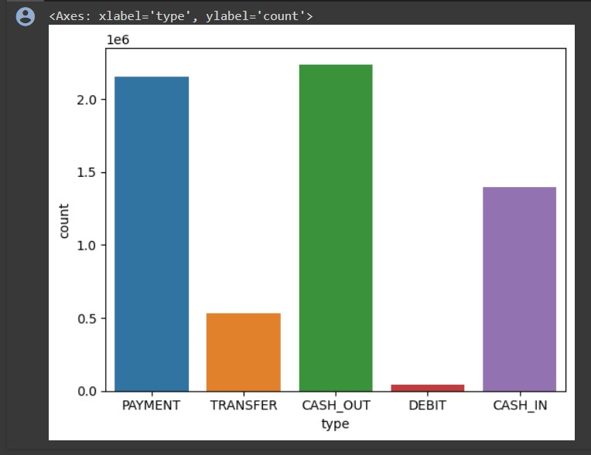

Displot
A distplot, short for distribu on plot, is a data visualiza on in Python o en created using the Seaborn library. It combines a histogram with a kernel density es mate to provide an overview of the data's distribu on

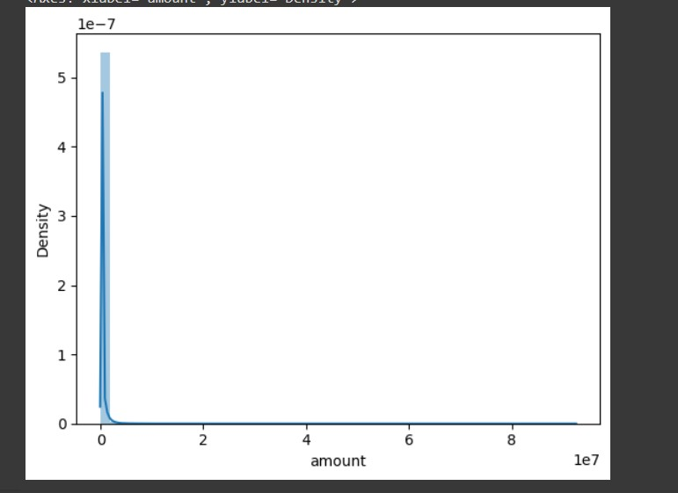

Hisplot
A histplot is a graphical representa on that displays the distribu on of a single variable through a histogram.
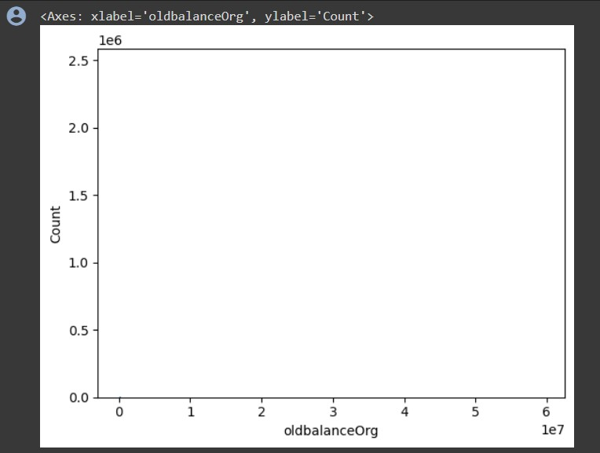

Countplot
A countplot is a type of bar plot that displays the frequency of categorical data in a dataset.
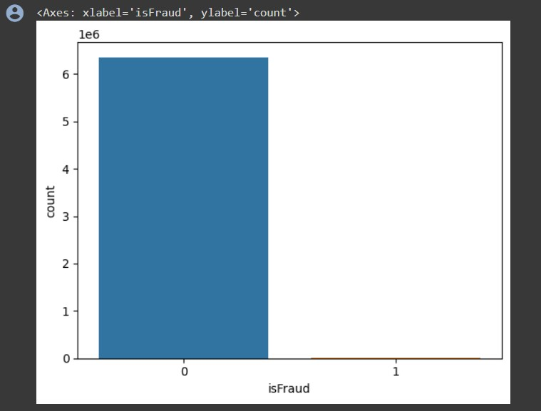

Coun ng the number of isFraud
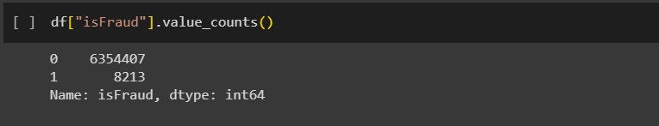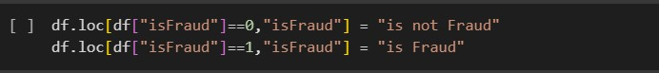

Mul variate Analysis
Mul variate analysis is a sta s cal technique used to analyze and understand rela onships among mul ple variables simultaneously, helping to iden fy pa erns and correla ons within complex data sets. It typically involves methods such as regression analysis, principal component analysis, or factor analysis to explore these rela onships.

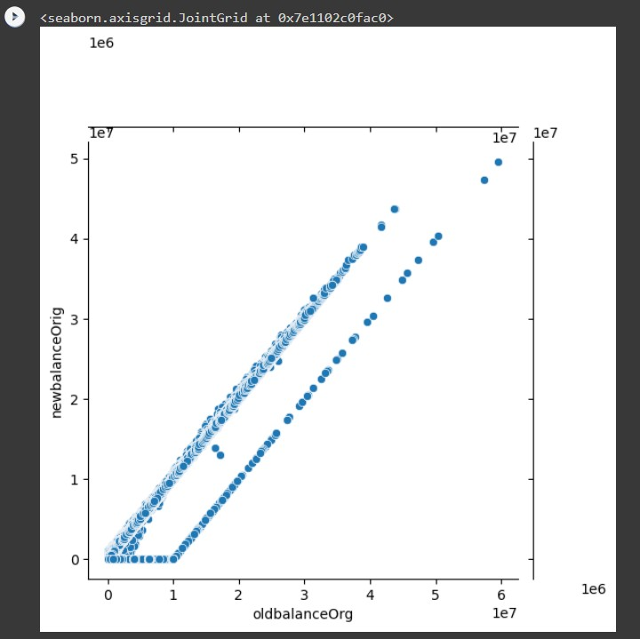

Sca erplot
A sca erplot is a graph that displays individual data points as dots to visualize the rela onship between two con nuous variables.
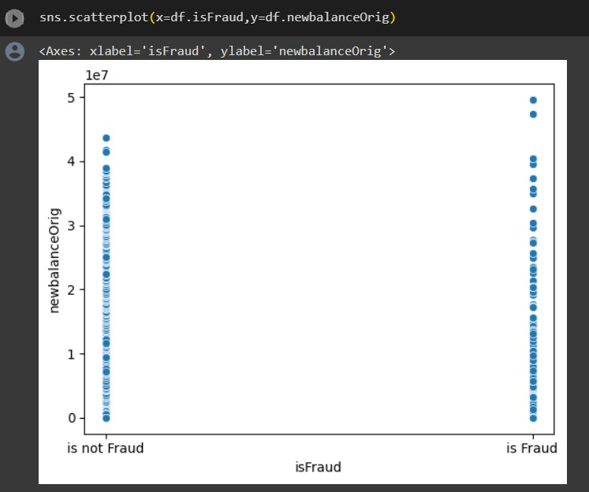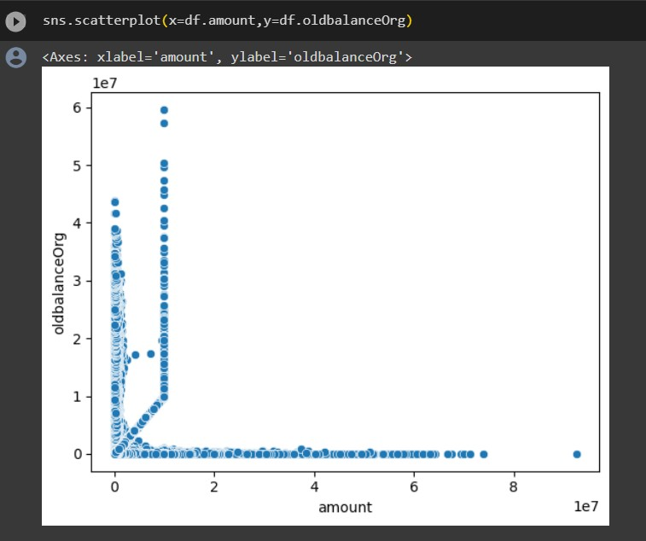

Heatmap
A heatmap is a graphical representa on that uses color to depict the rela onships and values of a matrix or two-dimensional data set.
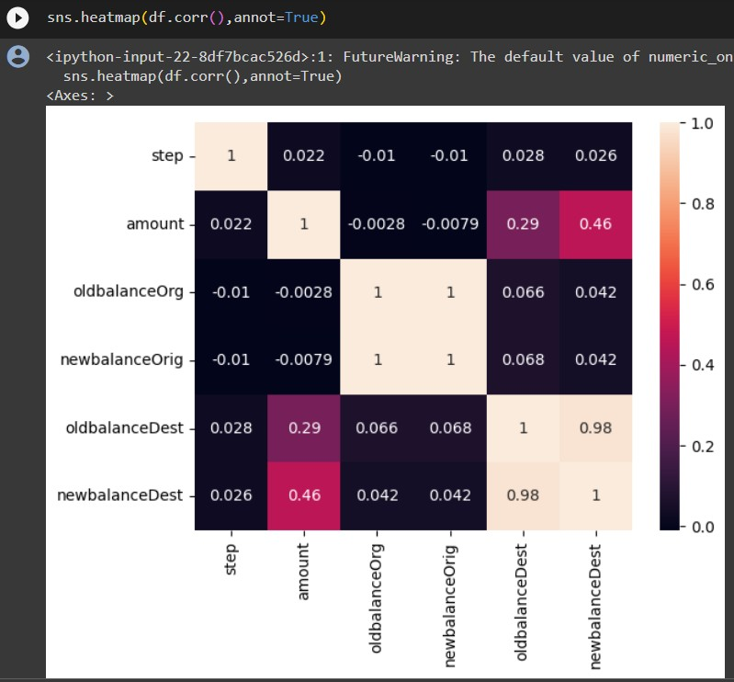

Data Preprocessing
The code removes the 'nameOrig' and 'nameDest' columns from the DataFrame 'df' by specifying the column names and the 'axis' parameter set to 1 (indica ng columns). The
'inplace=True' argument modifies the DataFrame directly. A er this opera on, the 'df'
DataFrame will have these columns removed from its structure.
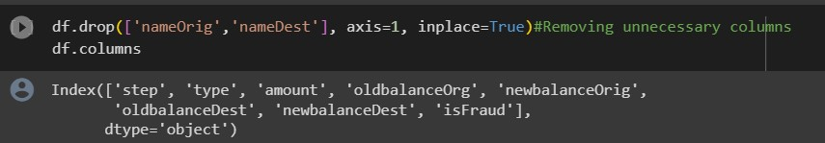

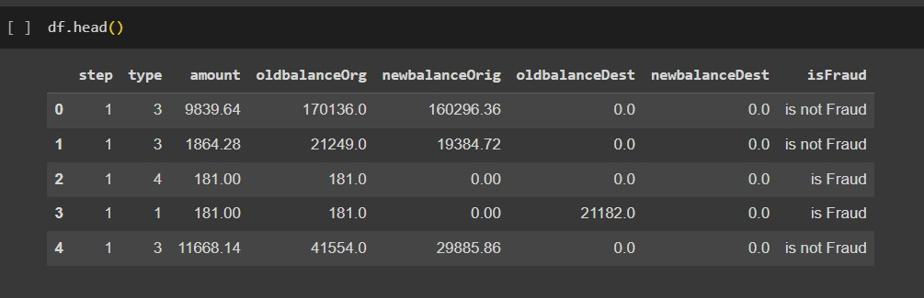

Removal of Outliers (Using Percen le Method)
The removal of outliers by the percen le method is a technique used to eliminate extreme data points in a dataset. To implement this method, first, you calculate the lower and upper percen le boundaries, o en using values like the 5th and 95th percen les. These boundaries help define the range within which the majority of the data points are expected to fall. Next, you iden fy data points that fall below the lower percen le boundary or exceed the upper percen le boundary, marking them as outliers. Finally, these iden fied outliers are removed from the dataset. This process results in a more robust dataset for analysis, as it reduces the impact of extreme values on sta s cal analyses and visualiza ons.

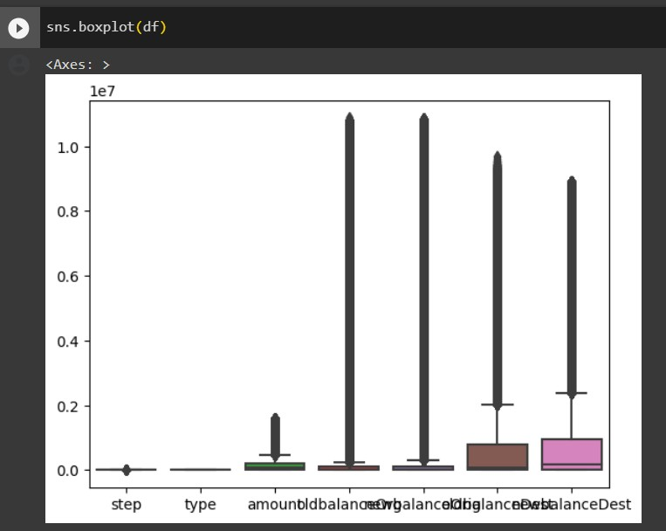

This code first iden fies numeric columns (excluding 'isFraud') and removes extreme outliers by calcula ng the 99th percen le for each column. It filters the DataFrame to keep only values below this threshold, making the data more suitable for subsequent analysis or modeling. Addi onally, this data preprocessing step helps improve the robustness of the dataset and ensures that extreme values do not unduly influence the analysis. It's a common prac ce to enhance the quality of numeric data before conduc ng further sta s cal or machine learning tasks.

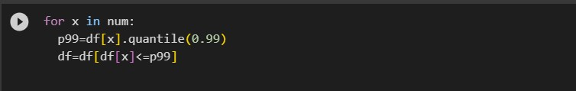
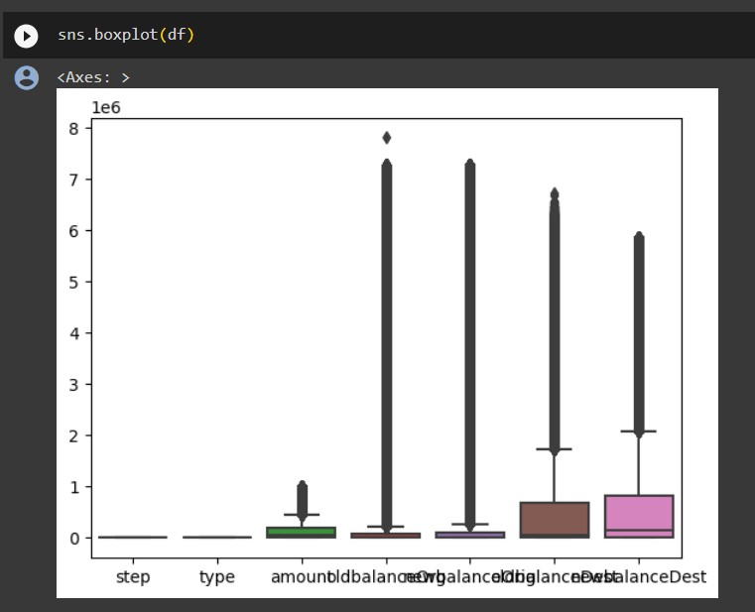

LABEL ENCODING
Label encoding is a fundamental technique in machine learning for conver ng categorical data into numerical format, a necessary step for many algorithms. In Python, it's commonly implemented using libraries like Scikit-Learn. First, you import the LabelEncoder class from Scikit-Learn. Then, you create an instance of the LabelEncoder class, which is used to transform the categorical data into numeric values. Finally, you apply the label encoder to a specific column in your DataFrame, effec vely conver ng the categorical labels into corresponding numeric values. This numeric representa on enables machine learning algorithms to work with the data, making label encoding a crucial preprocessing step in data analysis and modeling tasks.
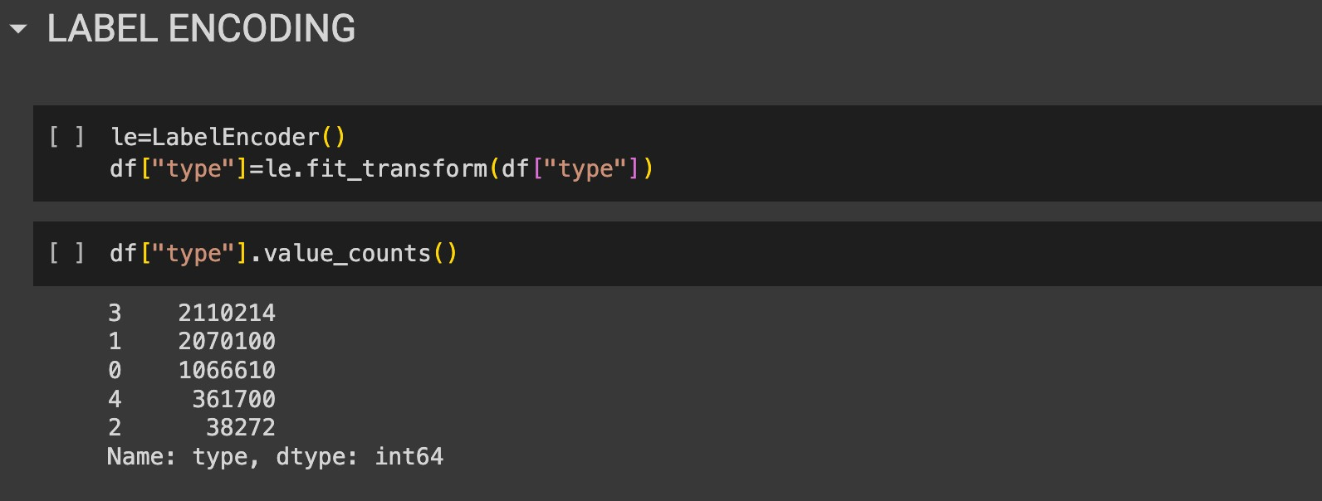

These two lines of code segment the dataset into independent variables (X) and the dependent variable (y). "X" includes all columns except "isFraud," while "y" contains only the "isFraud" column. This division prepares the data for supervised machine learning, where "X" represents the features used for predic on, and "y" is the target variable to predict.

Train Test split

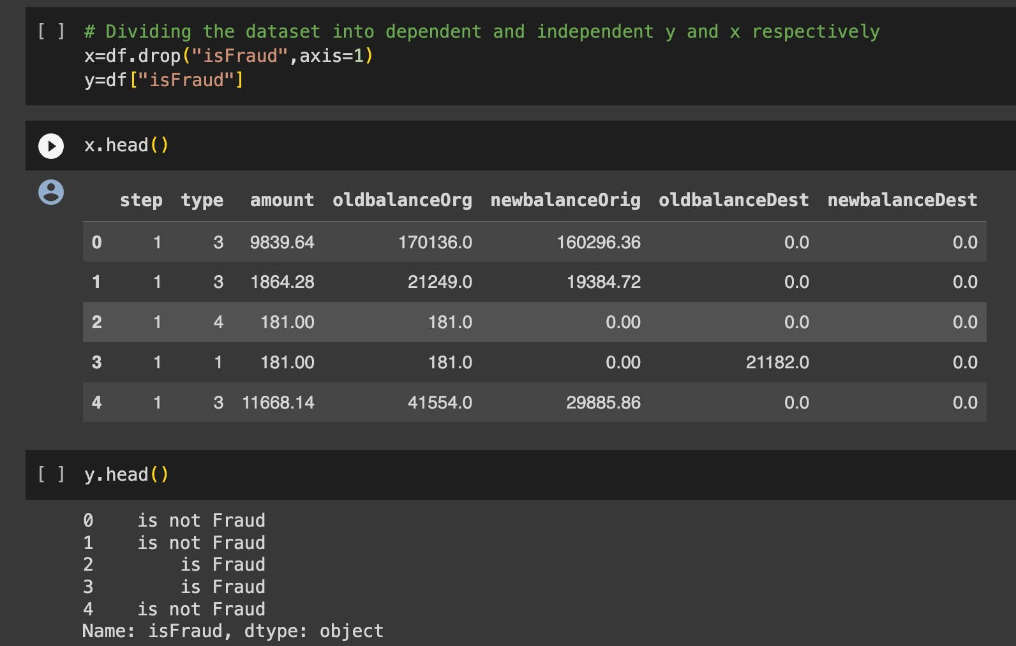

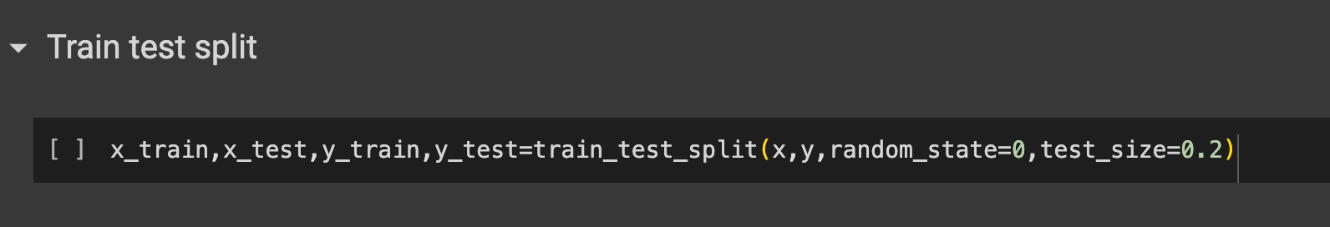

A train-test split is a common technique used in machine learning to evaluate the performance of a model. It involves dividing your dataset into two separate subsets: one for training the model and another for tes ng the model's performance.

To perform a train-test split:

- You start with your dataset, which typically includes both the features (input data) and the corresponding target values (output or labels).
- You specify a ra o, o en referred to as the "test size," which determines the propor on of your data to be set aside for tes ng. Common choices include 70/30, 80/20, or 90/10, with the training set being the larger por on.
- The data is then randomly divided into two subsets: the training set and the tes ng set. The training set is used to train your machine learning model, while the tes ng set is used to assess the model's performance by making predic ons and comparing them to the true values.

The train-test split helps you gauge how well your model generalizes to new, unseen data. It is a fundamental step in model evalua on and valida on, allowing you to check for overfi ng (when a model performs well on the training data but poorly on new data) and to es mate the model's predic ve accuracy on real-world data.

Random Forest Classifier
A Random Forest Classifier is an ensemble machine learning algorithm that combines mul ple decision trees to make more accurate predic ons. It's used for both classifica on and regression tasks. It improves predic on accuracy, handles overfi ng, and provides feature importance rankings by averaging the predic ons of mul ple decision trees. Random Forest is a versa le and powerful algorithm widely used in various applica ons, including image classifica on, medical diagnosis, and financial forecas ng.
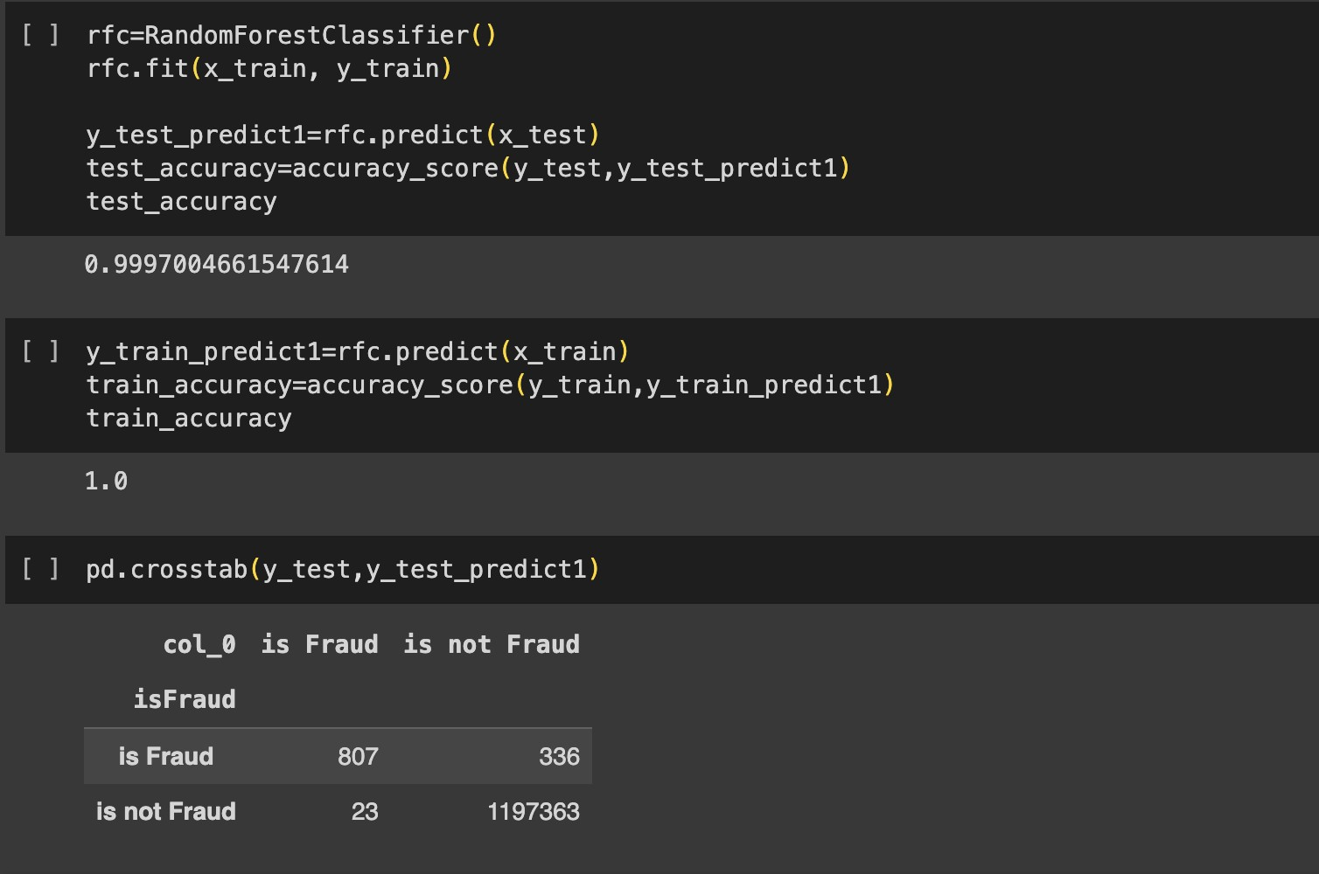

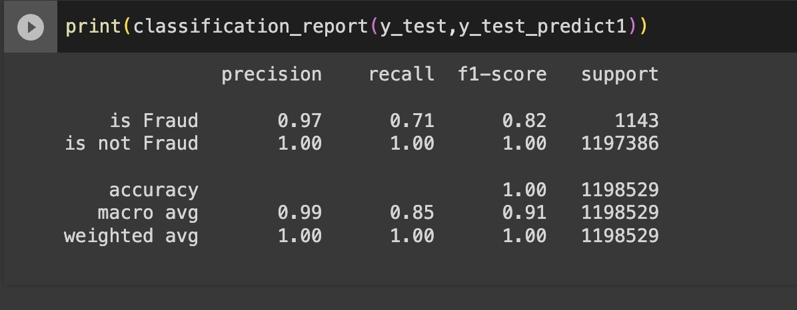

Decision Tree Classifier
A Decision Tree Classifier is a machine learning algorithm that creates a tree-like model to make predic ons. It's used for classifica on tasks, where it splits the data into subsets based on feature a ributes, ul mately assigning labels to instances. Decision trees are interpretable and easy to visualize, making them useful for understanding the decision-making process in a model. They can handle both categorical and numerical data, and by recursively spli ng the data based on the most informa ve features, decision trees are capable of capturing complex decision boundaries.

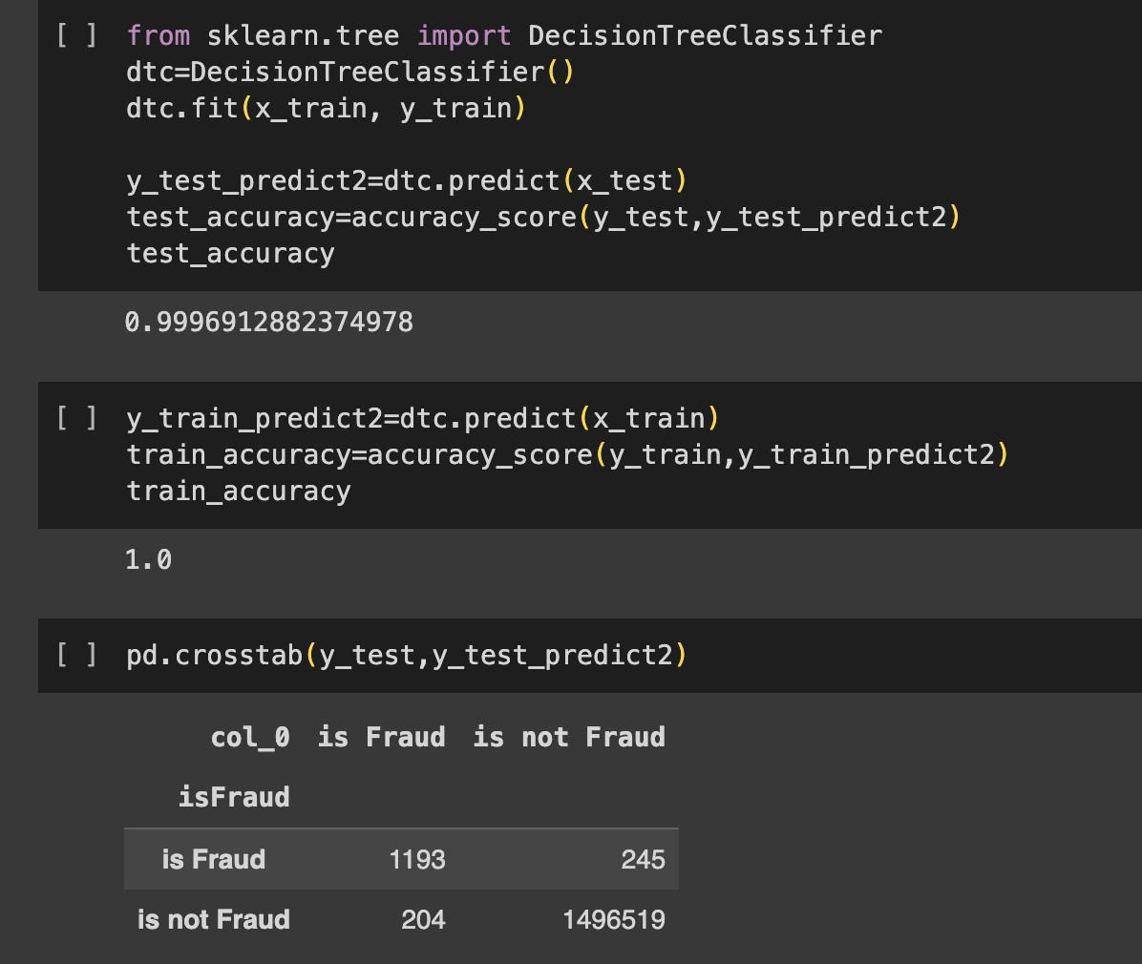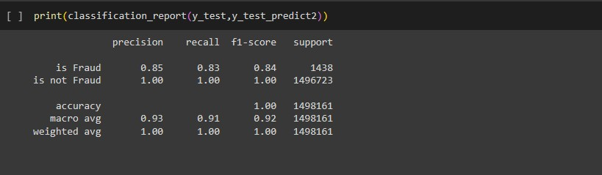

SVM
Support Vector Machine (SVM) is a powerful supervised machine learning algorithm used for both classifica on and regression tasks. It finds the op mal hyperplane that maximizes the margin between different classes in the data, making it effec ve for separa ng data points in high-dimensional spaces. SVM can handle linear and non-linear problems through techniques like kernel func ons, and it's known for its ability to handle complex decision boundaries while avoiding overfi ng. SVMs have applica ons in image recogni on, text classifica on, and more.

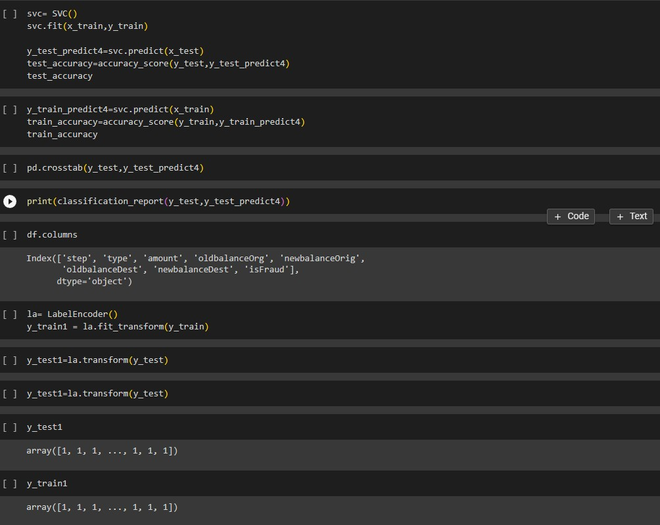

XgBoost Classifier
XGBoost, short for "Extreme Gradient Boos ng," is a popular and highly effec ve ensemble machine learning algorithm primarily used for classifica on and regression tasks. It enhances predic ve accuracy by combining the predic ons of mul ple decision trees. XGBoost uses gradient boos ng, which op mizes model performance by itera vely adding decision trees to correct errors made by the previous trees. It's known for its speed, scalability, and the ability to handle complex rela onships in the data, making it a top choice in data science compe ons and real-world applica ons like customer churn predic on and anomaly detec on.

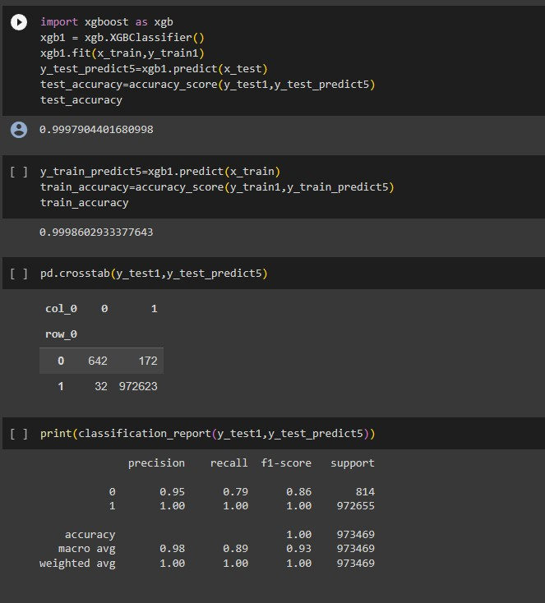

Result

We successfully implemented mul ple different Machine Learning Algorithms on the given dataset to determine which approach to use for our product. We implemented Random Forest, Decision Trees, SVM classifier, XgBoost classifier and obtained accuracies of 99.97, 99.96, 80 and 99.97 respec vely.
Hence, we concluded that the model which is best fit for the given dataset is 99.97 which is given by XgBoost as the recall for 0 and 1 is high as compared to other models

Applica on Building
In this sec on of the project, we will create a web applica on that interfaces with the machine learning model we previously developed. This applica on will include a user interface (UI) where users can input values for making predic ons. These input values will be forwarded to the saved machine learning model, and the predic ons generated will be displayed on the UI.

The tasks involved in this sec on are as follows:

- Building HTML Pages: We will design and create the web pages that make up the user interface. These pages will include forms or input fields where users can provide the necessary data for predic ons.
- Building Server-Side Script: We will develop the server-side logic, which is responsible for handling user input, passing it to the machine learning model, obtaining predic ons, and then presen ng the results back to the user on the UI.

This integra on of machine learning into a web applica on allows users to interact with the model and receive predic ons in a user-friendly manner, making it prac cal for various applica ons, such as recommenda on systems, fraud detec on, or any scenario where predic ve models need to be put into prac cal use.

Flask File
This code sets up a Flask web applica on for a machine learning model. It loads a pre-trained model from a saved pickle file, provides routes for different pages (about, home, predict), and handles form submission. When a user submits data on the 'predict' page, it passes the input to the model and displays the predic on on the 'result' page. The applica on runs in debug mode when executed as the main program, enabling web development and tes ng.

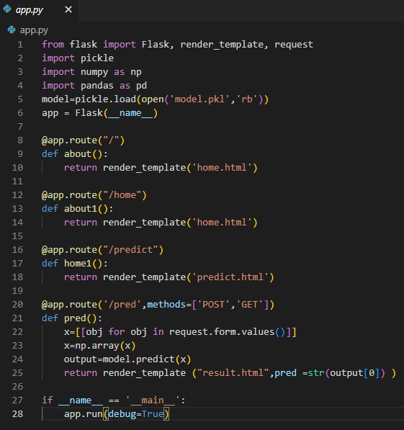

Our User Interface
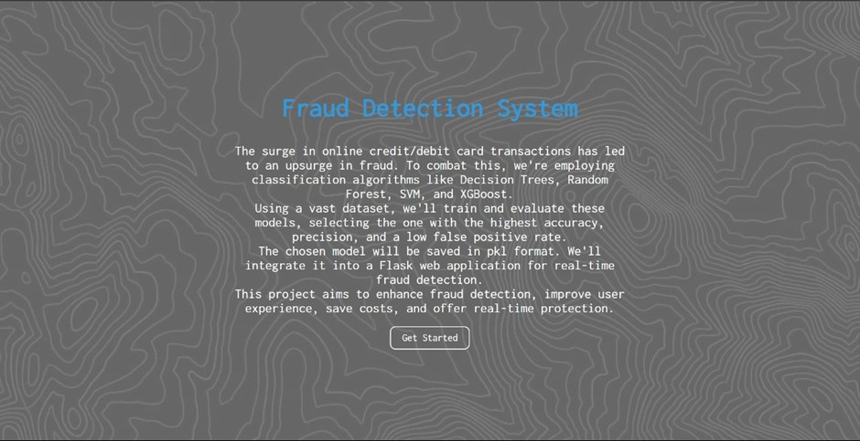
Form Page (User Input):

Form: Display a form with fields for users to input informa on related to a transac on for fraud detec on:
- 'step': [Input Field]
- 'type': [Input Field]
- 'amount': [Input Field]
- 'oldbalanceOrg': [Input Field]
- 'newbalanceOrig': [Input Field]
- 'oldbalanceDest': [Input Field]
- 'newbalanceDest': [Input Field]
- Submit Bu on: Provide a "Submit" bu on that allows the user to submit the transac on details for fraud detec on.

Result Display: A er submi ng the form, display the result on the same page. It may indicate whether the provided transac on informa on is classified as poten al fraud or not. For example:
"Result: No Fraud Detected" or "Result: Possible Fraud Alert"
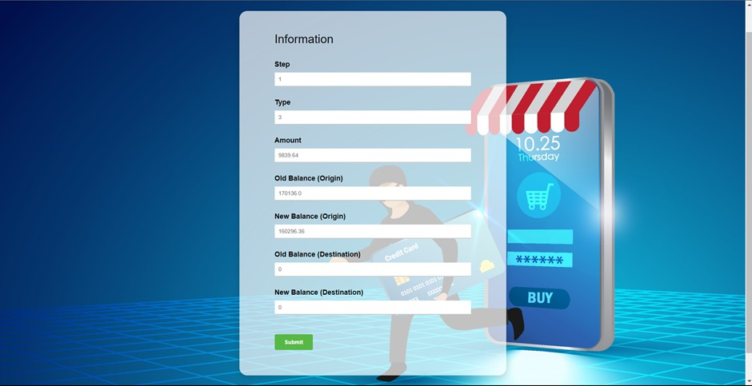

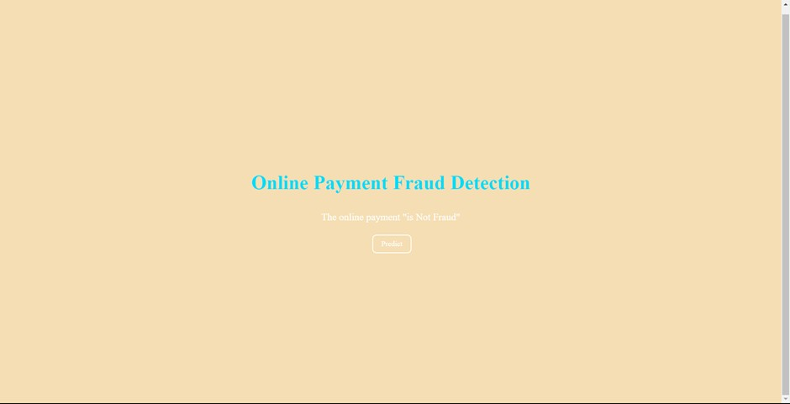

When the system classifies a transac on as "Not a Fraud," it means that the provided transac on details do not exhibit suspicious or fraudulent behavior.
Users can be reassured that the transac on appears legi mate, and they can proceed with confidence.
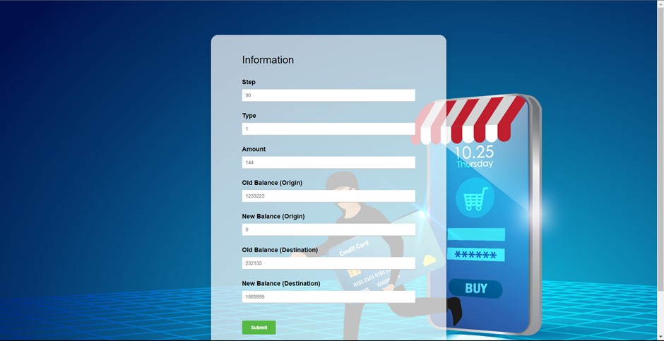

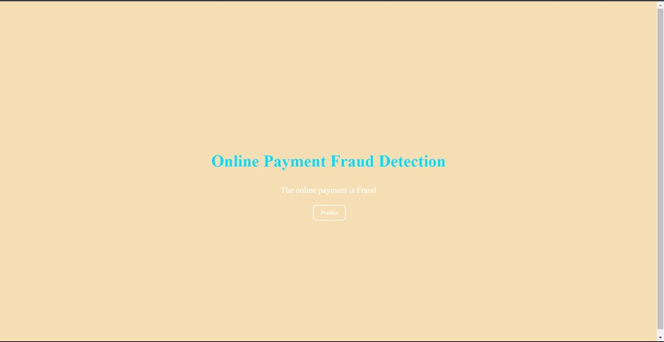

When the system classifies a transac on as "Fraud," it indicates that the provided transac on details raise suspicions of fraudulent ac vity.
Users should be alerted to the poten al risk and advised to take immediate ac on to secure their accounts and prevent further damage.
Thank You
Team - 592416
Team Members
- Aryan Sharma (21BBS0106)
- Arjun Malhotra (21BBS0110)
- Pranav Singh Mahara (21BBS0188)
- Kanishak Khanna (21BCI0147)

